Azure OpenAi notes

Playground: [Deployments | Azure OpenAI Studio](https://nam12.safelinks.protection.outlook.com/?url=https%3A%2F%2Foai.azure.com%2Fportal%2Fd3d5be3f55654a9fb6019f0eaee99cc2%2Fdeployment%3Ftenantid%3D8331e14a-9134-4288-bf5a-5e2c8412f074&data=05%7C02%7Csophia.yue%40kroger.com%7Cff6379d93f4f4d2f036408dbfdc63321%7C8331e14a91344288bf5a5e2c8412f074%7C0%7C0%7C638382799936090290%7CUnknown%7CTWFpbGZsb3d8eyJWIjoiMC4wLjAwMDAiLCJQIjoiV2luMzIiLCJBTiI6Ik1haWwiLCJXVCI6Mn0%3D%7C3000%7C%7C%7C&sdata=mGUt64%2BkIu%2FZ%2BrZE6drQqbdapvmJAwhaCvJeTB6zjYE%3D&reserved=0)

[Get resource information](https://oai.azure.com/portal/d3d5be3f55654a9fb6019f0eaee99cc2/deployment?tenantid=8331e14a-9134-4288-bf5a-5e2c8412f074)

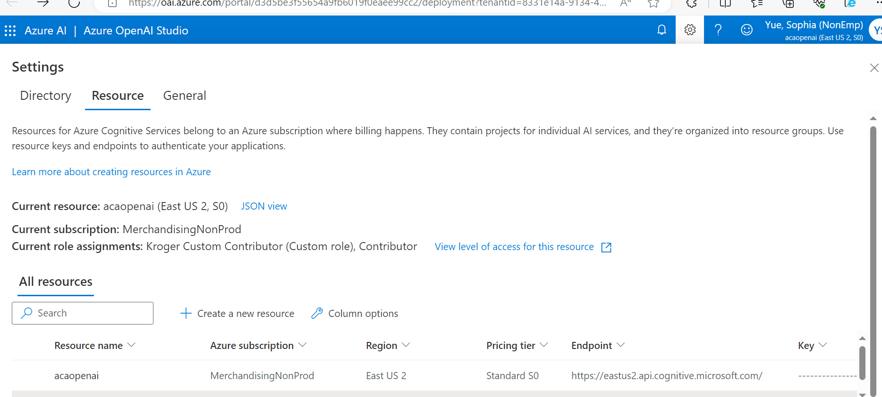

| **Models** | **Context** | **Prompt (Per 1,000 tokens)** | **Completion (Per 1,000 tokens)** |
| --- | --- | --- | --- |
| GPT-3.5-Turbo | 4K | **$0.0015** | **$0.002** |
| GPT-3.5-Turbo | 16K | **$0.003** | **$0.004** |
| GPT-3.5-Turbo-1106 | 16K | **$0.001** | **$0.002** |
| GPT-4-Turbo | 128K | **$0.01** | **$0.03** |
| GPT-4-Turbo-Vision | 128K | **$0.01** | **$0.03** |
| GPT-4 | 8K | **$0.03** | **$0.06** |
| GPT-4 | 32K | **$0.06** | **$0.12** |